# Question No 1:

#include<iostream>

using namespace std;

int main()

{

int x,count=1;

int sum = 0;

while (count <= 5)

{

cout << "enter a integer value:" << endl;

cin >> x;

sum = sum + x;

count++;

}

cout << "sum of integer values is:" << sum << endl;

system("pause");

return 0;

}

## Result:

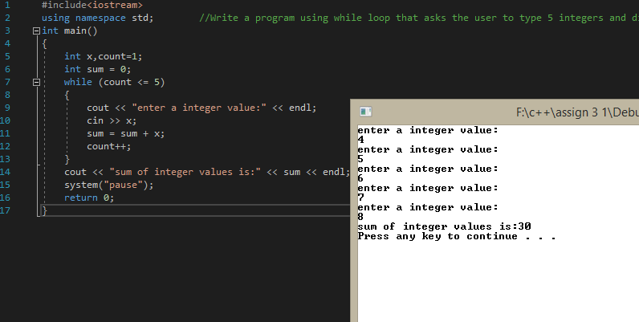

# Question No 2:

#include<iostream>

using namespace std;

int main()

{

int e, b;

int mul = 1;

cout << "enter base of value:" << endl;

cin >> b;

cout << "enter exponent of value" << endl;

cin >> e;

for (int x = 1; x <= e; x++)

{

mul = mul * b;

}

cout << "power of the number is: " << mul << endl;

system("pause");

return 0;

}

## Result:

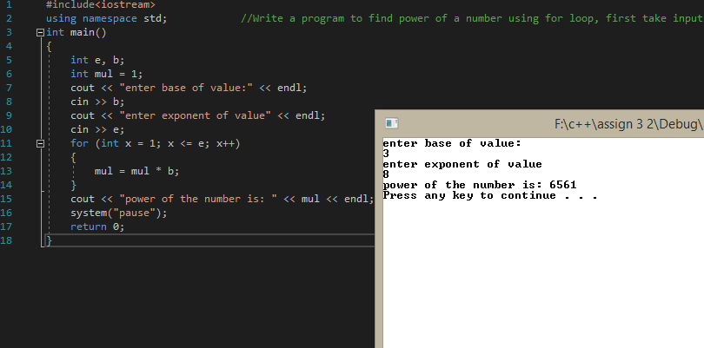

# Question No 3:

#include<iostream>

using namespace std;

int main()

{

int x, y=1;

int fact = 1;

cout << "enter a number for factorial: " << endl;

cin >> x;

while (y <= x)

{

fact = fact * y;

y++;

}

cout << "factorial of number is: " << fact << endl;

system("pause");

return 0;

}

## Result:

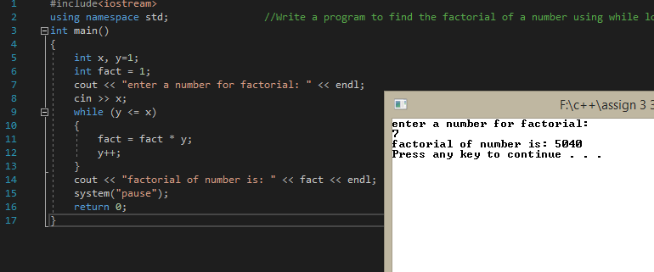

# Question No 4:

#include<iostream>

using namespace std;

int main()

{

int sum=0;

for (int x = 1; x <= 5; x++)

{

int fact = 1;

for (int y = 1; y <= x; y++)

{

fact = fact * y;

}

sum = sum + fact;

}

cout << "sum of series is: " << sum << endl;

system("pause");

return 0;

}

## Result:

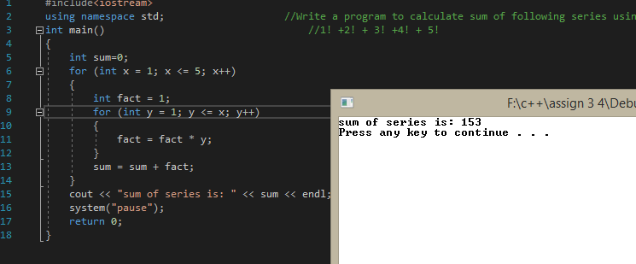

# Question No 5:

#include<iostream>

using namespace std;

int main()

{

int y, a;

int small;

cout << "enter a number:" << endl;

cin >> small;

for (int x = 1; x < 6; x++)

{

cout << "Enter a number again" << endl;

cin >> a;

if (a < small)

{

small = a;

}

}

cout << "Smallest of all the six integer is: " << small << endl;

system("pause");

return 0;

}

## Result:

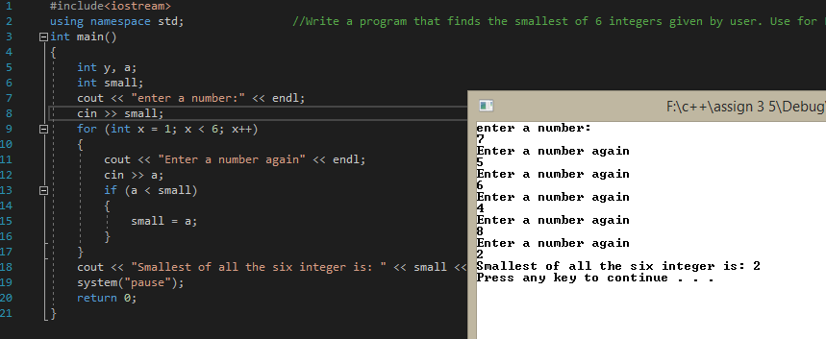

# Question No 6:

#include<iostream>

using namespace std;

int main()

{

int x, y;

cout << "enter the staring number" << endl;

cin >> x;

cout << "enter the ending number" << endl;

cin >> y;

for (int a = x; a <= y; a++)

{

if (a % 2 != 0)

{

cout << a << '\t';

}

}

cout << endl;

system("pause");

return 0;

}

## Result:

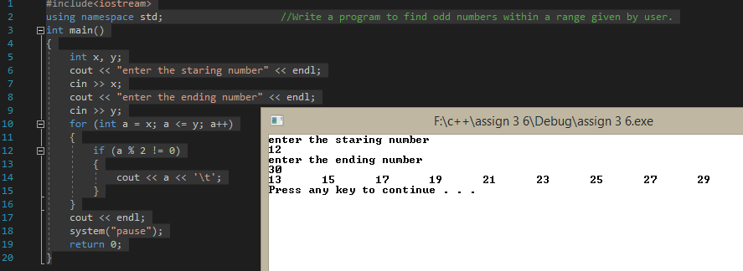

# Question No 7:

#include<iostream>

using namespace std;

int main()

{

int x,y=1;

cout << "Enter a number: " << endl;

cin >> x;

while (y <= x)

{

if (x%y == 0)

{

cout << y << '\t';

}

y++;

}

cout << endl;

system("pause");

}

## Result:

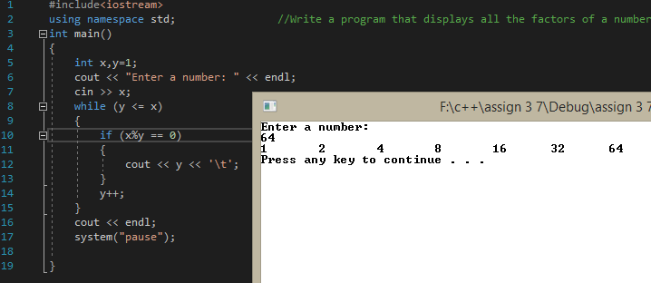

# Question No 8:

#include<iostream>

using namespace std;

int main()

{

int x, small, large;

cout << "enter a number: " << endl;

cin >> x;

small = x;

large = x;

while (x > 0)

{

if (x > large)

{

large=x;

}

else if (x < small)

{

small = x;

}

cout << "enter a number again: " << endl;

cin >> x;

}

cout << "smallest number of all numbers is: " << small << endl;

cout << "largest number of all numbers is: " << large << endl;

system("pause");

return 0;

}

## Result:

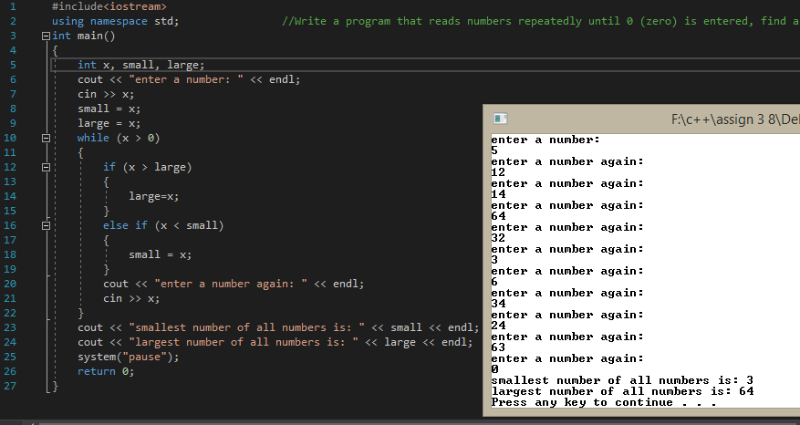

# Question No 9:

#include<iostream>

using namespace std;

int calculation()

{

int sum = 0;

for (int x = 50; x <= 150; x++)

{

if (x % 6 == 0)

{

cout << x << '\t';

sum = sum + x;

}

}

return sum;

}

void print(int a)

{

cout << endl << "sum of all the integers between 50 and 150 is: " << a << endl;

}

int main()

{

int s;

s = calculation();

print(s);

system("pause");

return 0;

}

## Result:

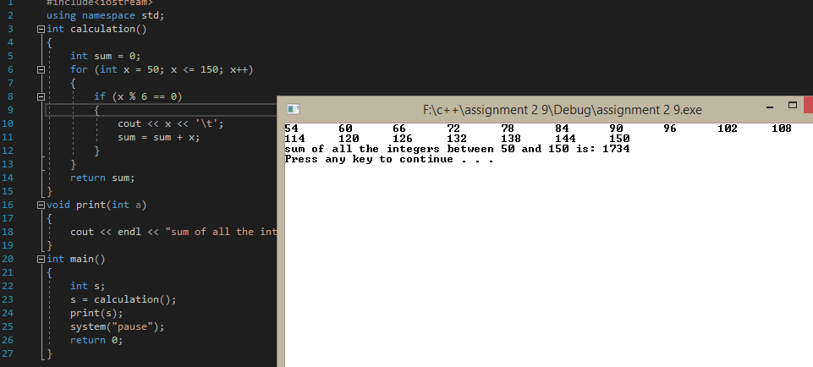

# Question No 10:

## Result: